Tyler Rempo

CS 110

12/13/20

Professor Ryan

Section 1: Overview and Summary of Project

My program extracts stock data from Yahoo Finance using numpy, pandas, and pandas_datareader. The program then takes this data, places it into a data frame and graphs the information using matplotlib. For my program specifically, I took the most popular index funds in the US and the value of Gold, Silver, and Crude Oil and compared these with a Tech Sector ETF created by BlackRock, iShares Expanded Tech Sector ETF, from January 1st, 2020 to the current day. The Tech sector ETF tracks stocks listed in the US from the technology sector. Here is what the User interface reads as well as a sample input and output:

This program will provide you with a graph of the cumulative returns of select index funds in the US

and the value of Gold, Silver, and Crude Oil compared to a Tech Sector ETF, IGM, over the past year.

Enter 1 if you would like to view this graph:

If you entered 1 the output would be: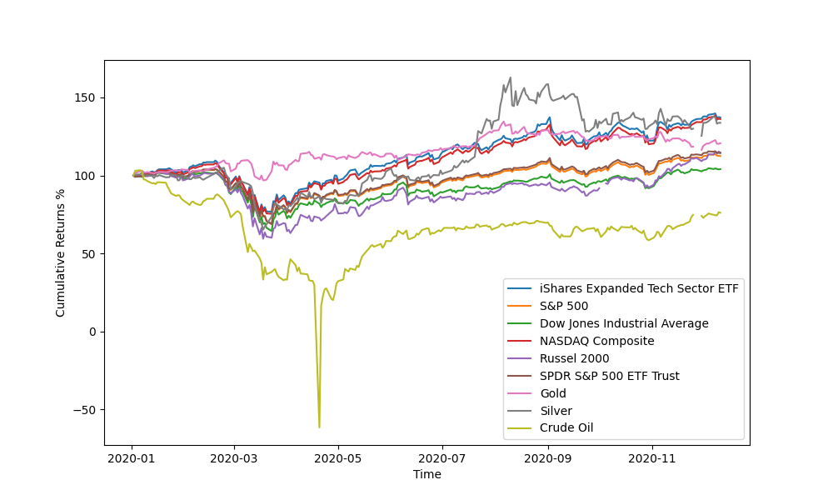

If you entered any other numerical value or string the output would be:

"Welp I guess you aren't interested in the graph."

Section 2: Target Audience

My primary audience are people involved in the finance industry. Specifically anyone who wants to know how the most popular index funds in the US and the value of Gold, Silver, and Crude Oil have performed compared to the Tech Sector since January 1st. Someone involved in the finance industry would be a user of my program because this year the technology sector has done extremely well, visualizing the performance of index funds and commodities to the technology sector could be useful for researching sector and index fund performance.

Section 3: Specific Programming Techniques Used

In the beginning of my program I used an If Else statement to ask the User whether or not they wanted to view the graph. If the User entered 1 it would run the code and display the stock graph, if the User entered anything else it would display the message, “Welp I guess you aren't interested in the graph.” I imported numpy, panda, and panda_datareader in order to extract and analyze stock data from Yahoo Finance and place it into a dataframe. Specifically used the DataReader library. I also imported matplotlib to place this data into a graph. I used a for statement to extract the stock info for each ticker listed, and calculate the cumulative return. I created another for statement to take the stock data and plot it.

Section 4: Challenges

The major challenges I faced were syntax, pandas, pandas_datareader and creating a function to find cumulative returns. There were a countless number of times I ran the program and was given a syntax error and had to reread my code. It was also difficult to learn to use pandas and pandas_datareader. I had to do a lot of reading and video watching to figure out how to use pandas and pandas_datareader, eventually I was able to figure out how to use it to extract stock data from yahoo finance, as well as set a specific start date and use the adjusted close price. Creating a function within my second for statement to find the cumulative return of each stock was also hard. While reading about pandas and pandas_datareader I also saw the lambda function often used in creating stock analysis programs. I used lambda because it allowed me to create a function without giving the function a name, and it allowed me to calculate cumulative return for each stock within my second for statement.

Section 5: Future Extensions

If I were to improve my program, I would find a way for the User to be able to input a tickers to display on the graph instead of solely using the Index Funds and commodities I placed in the code. I would also increase the number of colors that are used in the stock graph. There are only nine available colors for the graph, so it is difficult to know which line is which when surpassing extracting data from more than nine tickers in the code. I would also add the feature to create a candlestick graph and a bar chart.